# Introduction of SDGs

United Nations says that we still have some serious global problems in today's society. To solve these in 2030, United Nations prompted 17 interlinked global goals -------- Sustainable Development Goals (SDGs).

The SDGs cover a range of social and economic development issues which help us to create a better future for all humans. We have chosen three topics and identified the logical connections between them. They are "Zero hunger", "Good Health and Well-being", "Reduced Inequalities".

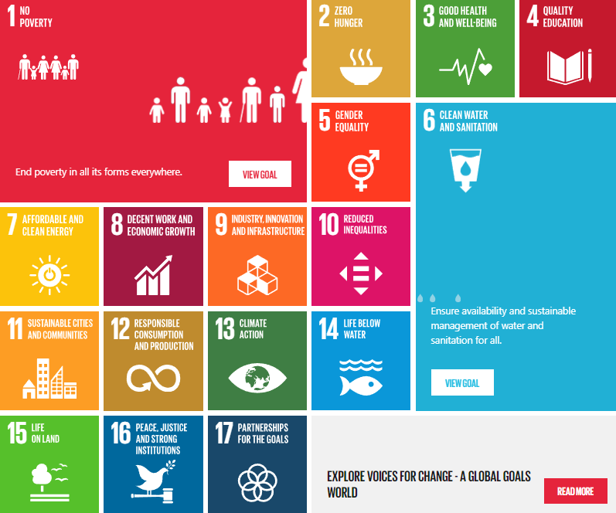

figure 1 Picture of global goals for sustainable development

As for SGD2, titled "Zero Hunger", aims to not only solve the problem of the hunger, but also improve the nutrition and security.Currently, 815 million individuals are malnourished, while up to two billion experience deficiencies in essential micronutrients.[1] The COVID-19 and War have influenced existing food security and supplying which causes 83 to 132 million people into hunger in 2020 alone. If recent trends continue, the number of people will surpass 840 million by 2030. This highlights the interconnection of global events and food security, emphasizing the necessary for sustainable food systems. Research indicates that the per capita availability of food on both a global and regional scale has steadily risen over the past few decades, suggesting that the global supply of food was not the root cause of the food crisis. Instead, the crisis stemmed from unequal access to food due to vast disparities in purchasing power among individuals and significant fluctuations in global food prices linked to trade. This situation emerged from a decline in planning and regulatory effectiveness at all levels, leading to a worldwide food system crisis (Headey 2011) that posed risks to the global economy and fueled political unrest across the globe.[2] We choose this title as one of our mini-project and want to search some information about the application of unmanned drone in the agriculture.

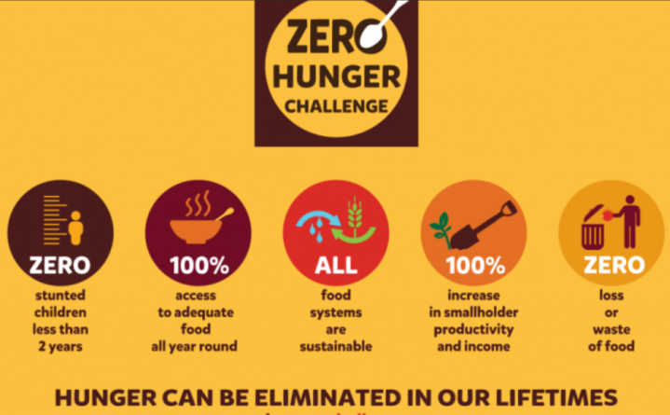

figure 2 Ways to achieve the goal of zero hunger

Within SDG3, Good Health and Well-Being, the project focuses on healthy lives and promote well-being for all people in different ages. The third Sustainable Development Goal (SDG), focused on ensuring good health and well-being, is particularly relevant today due to the worldwide health challenges presented by severe pandemics, such as the recent COVID-19 outbreak. These pandemics have the potential to hinder both national and global efforts towards accomplishing the goals set for 2030.[3] There are some stark figures – A woman dies every 2 minutes from preventable causes related to pregnancy and childbirth in 2020. 25 million children missed out on important routine immunizations in 2021 and 6 million more than in 2019. Therefore, it's very urgent to solve such various health issues, including child health, communicable and non-communicable diseases. These issues also remind us the importance of prepared health systems and the need for global health security to prevent and manage future health risks. According to the aggregated data from the years 2001 to 2014, their analysis revealed a life expectancy disparity of 14.6 years between the wealthiest and poorest 1% of men, and a 10.1-year difference for women. Moreover, life expectancy and its fluctuations over this period showed significant regional variations.[4] Therefore, we decide to search the information about rehabilitation devices which are portable and helpful to aid and improve patients’ daily rehabilitation activities.

The SDG 10 is about reduce inequality within and among countries, wage disparities, migration, and access to resources. There are some details of inequality. For examples, the first one is that the tragic loss of nearly 7,000 lives along migratory routes in 2022. Another one is like women are 2 times as likely as men to report experiencing discrimination based on their sex globally. After the crisis of COVID-19 which has enlarged global income inequality, it highlights the need for robust recovery efforts, particularly in emerging markets and developing economies. The models indicate that by 2030, over 600 million individuals will still be living in extreme poverty, defined as earning less than $1.90 per day, leading to a worldwide extreme poverty rate of 7.4%.[5]A common rationale supporting price stability highlights the uneven impact of inflation tax, particularly when wealth is distributed unevenly and the asset portfolios of less affluent households are disproportionately composed of cash holdings. This imbalance results in the inflation tax burden falling more heavily on the economically disadvantaged.[6] One important and severe situation is that almost the majority of people with hearing loss are living in developing countries which lack health care and resources for hearing loss. To solve this inequality, our group have found some papers which focus on inexpensive hearing aid for them.

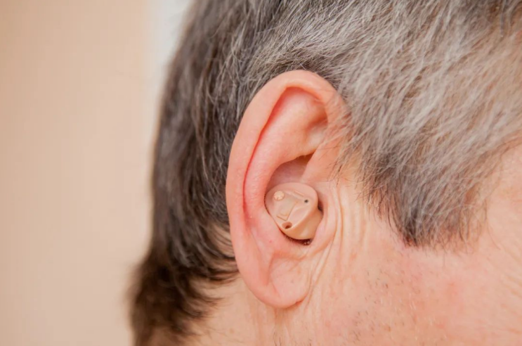

figure 3 A kind of hearing-aid with lower price has been widely used.

# Projects related to selected goals.

After selecting the goals, we want to achieve or address, it’s time to start to find the projects related to. There are three projects which are suitable for our targets.

## Precision Agriculture and Unmanned Aerial Vehicles

One of the most important things to address the hunger problem all over the world is to make full use of the arable land. From 1980s to 2020s, the reason of the improve of the production of rice is due to the hybrid rice yield increases rather than increase of the arable land.[7] In India, approximately 80% of the nation's total agricultural land is segmented into parcels smaller than 5 acres each. A significant portion of the agricultural produce relies on rainfall, with close to 45% of farming land receiving irrigation. This scenario reveals that about 55% of India's population is engaged in agriculture that predominantly depends on monsoon rains.[9] The way to increase area of arable is to use the Unmanned Aerial Vehicles, which not only can water some hard-to-reach farmland to improve the utility of the land, but also can use the machine learning algorithms to optimizing crop output.[8]

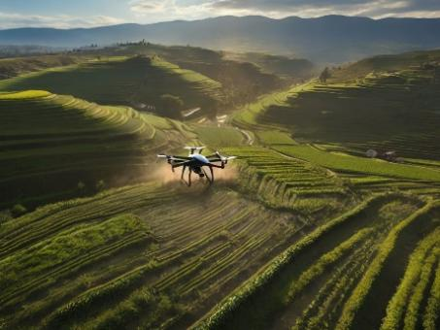

figure 4 Picture of drones working in terraced fields (left) and drones performing image recognition of farmland through machine learning (right), reproduced from [8]

For example, Pena et al. [10] scored up to 91% efficiency in sunflower fields with the help of a UAV. They using images collected by drones, combined with object-based image analysis (OBIA) processing, weeds can be accurately identified at an early stage. Weeding at this time can effectively prevent the occurrence and spread of weeds, thereby reducing crop competition pressure and indirectly improving Crop yield.

## Using muscle sensors in rehabilitation devices.

The health of the human body improved a lot in the recent year. While there still have a lot of Vulnerable Groups we ignored, such as the Stroke people. Most of the people have stroke since the age. At the same time, the world is gradually entering an aging society, thus the number of people getting stroke increases sharply.[11] And consequently, the recovery is becoming more and more important. Previous research on home rehabilitation processes has shown improvements in facilitating human motor recovery. However, existing rehabilitation devices are expensive and require the supervision of a physical therapist. Due to their large size and complex systems, some devices are not very efficient for use at home. Portable and simple home rehabilitation devices can aid patients in improving their daily rehabilitation activities.[12]

figure 5 An image of an EMG sensor detecting muscle electrical signals, reproduced from [12].

For example, Dai et al [13] examined the use of electromyography (EMG) in measuring stroke effects. Findings showed significant changes in muscle coherence post-stroke, indicating potential origins of muscle activation disorders. A novel pattern recognition technique was introduced for differentiating functional movements in stroke survivors. Overall, the study provides insights for assessing muscle function and developing targeted rehabilitation strategies.

## Digital behind-the-ear hearing aid

Approximately 90% of people with hearing loss reside in low- and middle-income countries, which often lack resources and strategies to address hearing loss. Individuals with hearing loss often encounter heightened levels of frustration, anxiety, irritability, depression, and disorientation compared to those with normal auditory capabilities. To reduce the unfairness, it is important to research an inexpensive hearing aid for developing countries. The standard rehabilitation tool for hearing impairment is an electronic hearing aid whose main components are transducers (microphone and receiver) and a digital signal processor.[14]

figure 6 The number and total number of hearing-impaired people in different age groups around the world, data from WHO.

For example, there is a digital hearing aid utilizes MEMS technology and achieves low cost and high efficiency through the measurement of MEMS loudspeaker vibration displacement using an optical interferometer. This technology addresses issues such as high cost, large size, and short battery life found in traditional hearing aids, bringing new possibilities to the hearing aid market.[15]

[1] Jennifer Blesh, Lesli Hoey, Andrew D. Jones, Harriet Friedmann, Ivette Perfecto, Development pathways toward “zero hunger”, World Development, Volume 118, 2019, Pages 1-14, ISSN 0305-750X.

[2] Caron, P., Ferrero y de Loma-Osorio, G., Nabarro, D. et al. Food systems for sustainable development: proposals for a profound four-part transformation. Agron. Sustain. Dev. 38, 41 (2018).

[3] Sweileh, W.M. Bibliometric analysis of scientific publications on “sustainable development goals” with emphasis on “good health and well-being” goal (2015–2019). Global Health 16, 68 (2020).

[4] Woolf SH, Purnell JQ. The Good Life: Working Together to Promote Opportunity and Improve Population Health and Well-being. JAMA.

[5] Lakner, C., Mahler, D.G., Negre, M. et al. How much does reducing inequality matter for global poverty. J Econ

[6] Inequal 20, 559–585 (2022). Lorenzo Menna, Patrizio Tirelli, Optimal inflation to reduce inequality, Review of Economic Dynamics, Volume 24, 2017, Pages 79-94, ISSN 1094-2025

[7] Gerlach, C., 2024. How the World Hunger Problem Was not Solved.

[8] Sabir, R.M., Sarwar, A., Safdar, M. and Al Ansari, M.S., 2024. Precision Agriculture and Unmanned Aerial Vehicles (UAVs). In Agriculture and Aquaculture Applications of Biosensors and Bioelectronics (pp. 83-105). IGI Global.

[9] Gupta, S.K., Kumar, R., Limbalkar, O.M., Palaparthi, D. and Divte, P.R., 2019. Drones for future agriculture. AGRICULTURE & FOOD: e-newsletter, 16.

[10] Peña, José M., et al. "Quantifying efficacy and limits of unmanned aerial vehicle (UAV) technology for weed seedling detection as affected by sensor resolution." Sensors 15.3 (2015): 5609-5626.

[11] Ambar, Radzi Bin, et al. "Multi-sensor arm rehabilitation monitoring device." 2012 International Conference on Biomedical Engineering (ICoBE). IEEE, 2012.

[12] Li, Raymond C., et al. "The development, validity, and reliability of a manual muscle testing device with integrated limb position sensors." Archives of physical medicine and rehabilitation 87.3 (2006): 411-417.

[13] Klein, Cliff S., et al. "electromyography (EMG) techniques for the assessment and rehabilitation of motor impairment following stroke." Frontiers in neurology 9 (2018): 1122.

[14] Ferreira Bento, Ricardo, and Silvio Pires Penteado. "Designing of a digital behind-the-ear hearing aid to meet the World Health Organization requirements." Trends in Amplification 14.2 (2010): 64-72.

[15] Je, Sang-Soo, et al. "A compact and low-cost MEMS loudspeaker for digital hearing aids." IEEE Transactions on Biomedical Circuits and Systems 3.5 (2009): 348-358.